Title: | Airbag Control Unit  SW Design for the Airbag Control Unit

History
Issue status  (Index) | Maturity/Date  (draft/invalid/valid)  (dd-mmm-yyyy) | Author  Department | Check/Release  Department | Description
1.0 | Draft  07-Dec-17 | Antonio Vázquez | TEAM | General Information of the module for the first design revision downloaded.
2.0 | Draft  07-Dec-17 | Antonio Vázquez | TEAM | Functional Architecture Diagram and Functional Decomposition for the ACU and SBRD added.
3.0 | Draft  07-Dec-17 | Guillermo Hernández | TEAM | Functional Decomposition for the ACU and SBRP added.
4.0 | Draft  11-Dec-17 | Habib Apez | TEAM | Functional decomposition for the Passenger Occupancy Module added

Table of Contents
1 Purpose 4
2 Definitions and abbreviations 4
3 Realization constraints and targets 5
4 SW Conceptual design 5
4.1 Functional Architecture Diagram 5
5 SW Component internal breakdown 5
5.1 Functional Decomposition 5
5.1.1 General Functional Decomposition of the Airbag Control Unit 5
5.1.2 Functional Decomposition of the Seat Belt Reminder-Driver 6
5.2 Function Description and Dynamic Behavior 6

Purpose
Develop the design of the SW for an Airbag Control Unit based on the client requirements and using the V development work method. The development follows the Hungarian Name convention and uses Tortoise for uploading the documentation and code files to GitHub Repositories for managing version control.

Definitions and abbreviations
Definitions

Abbreviations
ACU | Airbag Control Unit
PSS | Passive Safety & Sensorics
References
N° | Document name | Reference
1 | PSS_ACU Requirements.doc | Documentation/V_Cycle Process/1.0 Requirements
2 | Requirements Review.docx | Documentation/V_Cycle Process/1.0 Requirements
3 | AEP_PSS_ACU_Traceability_Matrix.xls | Documentation/V_Cycle Process/1.0 Requirements
4 | AEP CAN database.xlsx | Documentation/V_Cycle Process/1.0 Requirements

Realization constraints and targets

SW Conceptual design

Functional Architecture Diagram
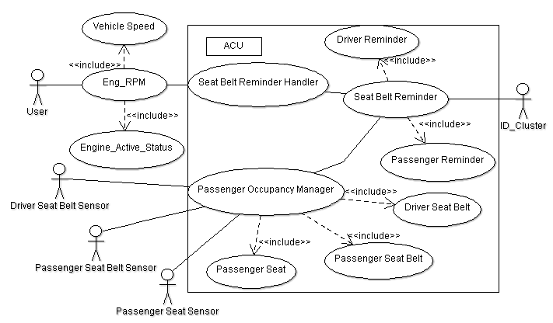

Physical Architecture Diagram

SW Component internal breakdown

Functional Decomposition

General Functional Decomposition of the Airbag Control Unit
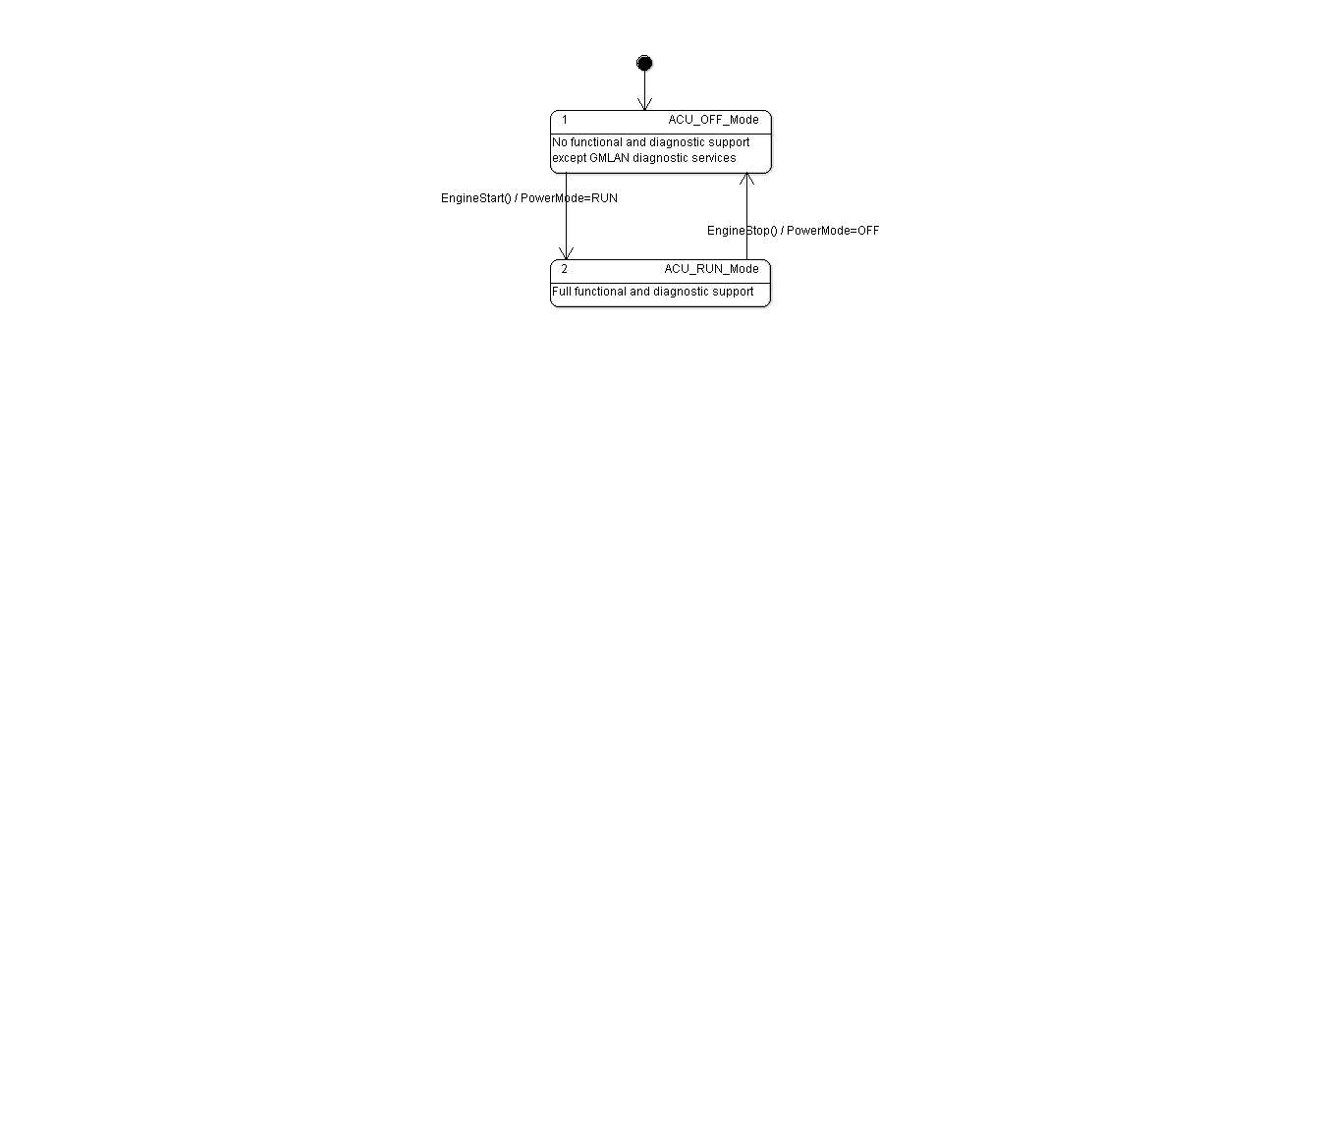

Functional Decomposition of the Seat Belt Reminder-Driver
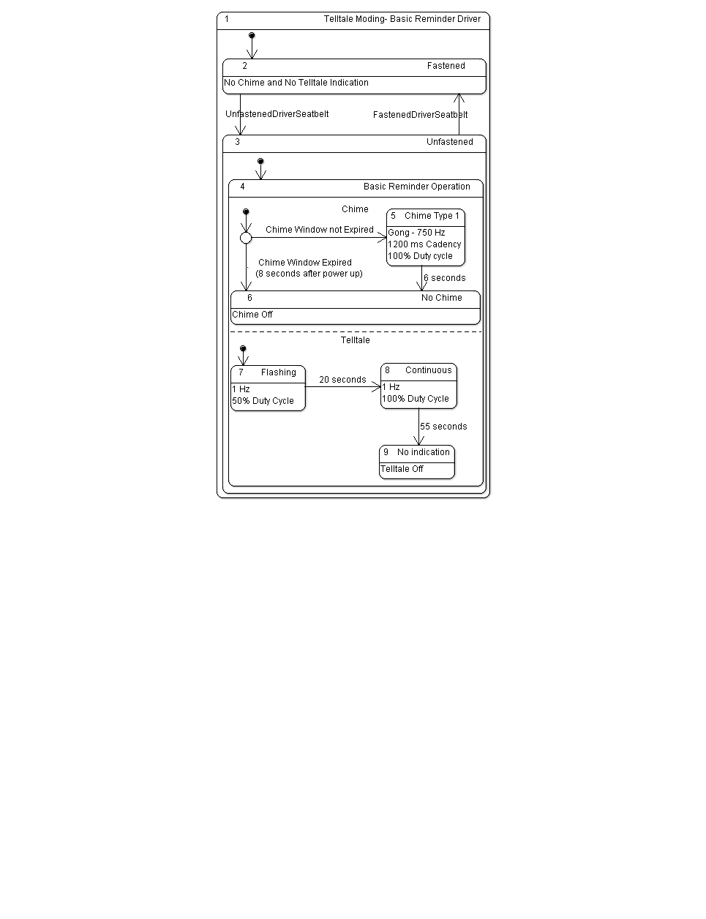

Functional Decomposition of the Seat Belt Reminder-Passenger
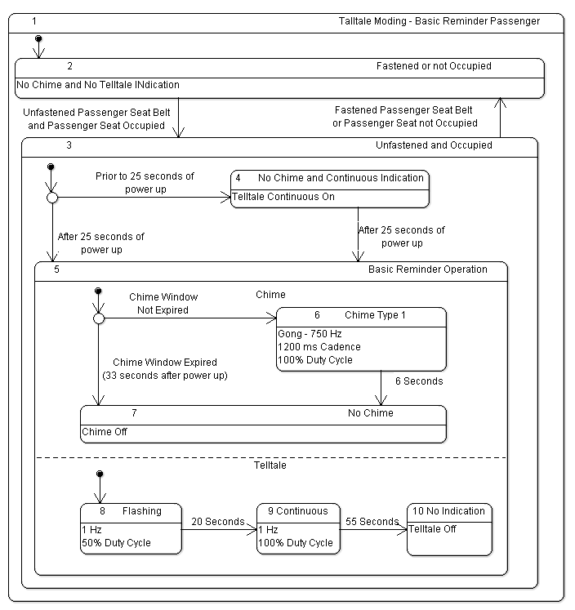

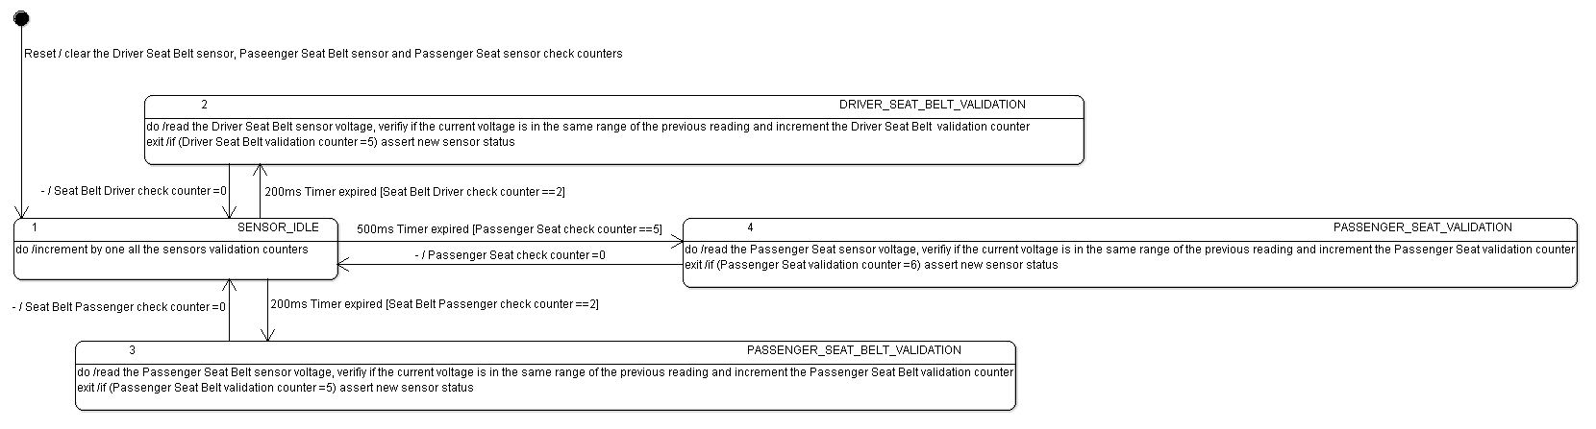
Functional Decomposition of the Passenger Occupancy Manager

Function Description and Dynamic Behavior

